3. The online bus ticket booking system enables users to search for buses by route, date, and time, and view available seats. Users can create an account, log in, and manage their bookings through a personal dashboard. The booking process includes selecting seats, filling out passenger details, and making secure payments via an integrated payment gateway. Admins can manage bus schedules, seat availability, and user accounts through an admin panel. Users receive booking confirmation emails and can view their booking history. The website is mobile-responsive, ensuring easy access on all devices.
AIM:
To develop a responsive Bus Ticket Booking System that allows users to register, log in, search buses by route and date, select seats, book or cancel tickets, view booking history, and post comments. The administrator can manage bus categories, bus details, schedules, seat availability, registered users, news, and reports.
SAMPLE CODE:
<!DOCTYPE html>
<html>
<head>
<title>Bus Ticket Booking</title>
<style>
body { font-family: Arial; margin: 25px; background: #f2f6f8; }
section { background: white; padding: 15px; margin: 12px 0; }
input, button { padding: 9px; margin: 4px; }
button { background: #18546b; color: white; border: 0; }
</style>
</head>
<body>
<h1>Bus Ticket Booking System</h1>
<section>
<h2>Search Buses</h2>
<input id="from" placeholder="From">
<input id="to" placeholder="To">
<input id="date" type="date">
<button onclick="searchBuses()">Search</button>
<div id="results"></div>
</section>
<section>
<h2>Passenger Details</h2>
<input id="passenger" placeholder="Passenger name">
<input id="email" type="email" placeholder="Email">
<div id="bookings"></div>
</section>

<section>
<h2>Admin: Add a Bus</h2>
<input id="busName" placeholder="Bus name or category">
<input id="busFrom" placeholder="From">
<input id="busTo" placeholder="To">
<button onclick="addBus()">Add Bus</button>
</section>
<script>
const buses = [
{ name: "Volvo Coach", from: "Chennai", to: "Bengaluru", seats: 20 },
{ name: "Sleeper Coach", from: "Chennai", to: "Coimbatore", seats: 15 }
];
const bookings = [];
function searchBuses() {
const from = document.getElementById("from").value.toLowerCase();
const to = document.getElementById("to").value.toLowerCase();
const matches = buses.filter(bus =>
bus.from.toLowerCase().includes(from) &&
bus.to.toLowerCase().includes(to) &&
bus.seats > 0
);
document.getElementById("results").innerHTML = matches.map(bus => `
<p>${bus.name}: ${bus.from} to ${bus.to}
— ${bus.seats} seats available
<button onclick="book('${bus.name}')">Book Seat</button></p>
`).join("") || "No buses found.";
}
function book(busName) {
const name = document.getElementById("passenger").value.trim();
const email = document.getElementById("email").value.trim();
if (!name || !email) {
alert("Enter your name and email first.");
return;
}
const bus = buses.find(item => item.name === busName);
bus.seats--;
bookings.push({ name, email, bus: busName });
alert("Ticket booked. Payment is simulated.");
showBookings();
searchBuses();
}
function showBookings() {
document.getElementById("bookings").innerHTML =
bookings.map((booking, index) => `
<p>${booking.name} — ${booking.bus}
<button onclick="cancelBooking(${index})">Cancel</button></p>
`).join("");
}
function cancelBooking(index) {
const booking = bookings.splice(index, 1)[0];
buses.find(bus => bus.name === booking.bus).seats++;
showBookings();
searchBuses();
}
function addBus() {
buses.push({
name: document.getElementById("busName").value,
from: document.getElementById("busFrom").value,
to: document.getElementById("busTo").value,
seats: 20
});
alert("Bus added.");
searchBuses();
}
</script>
</body>
</html>
SAMPLE OUTPUT
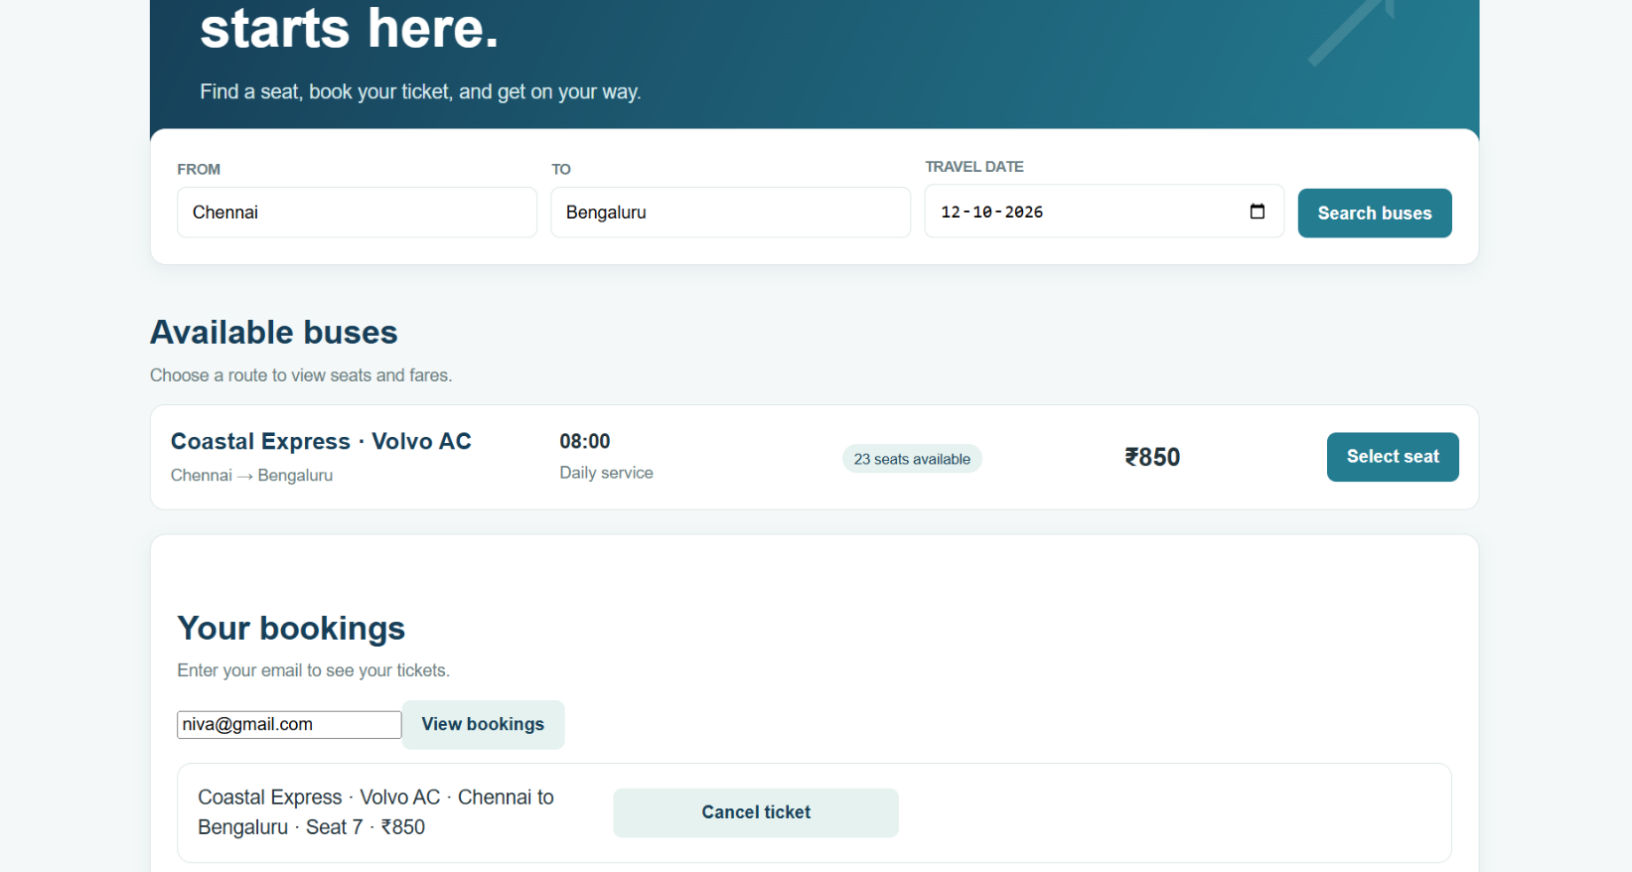
PASSENGER VIEW:

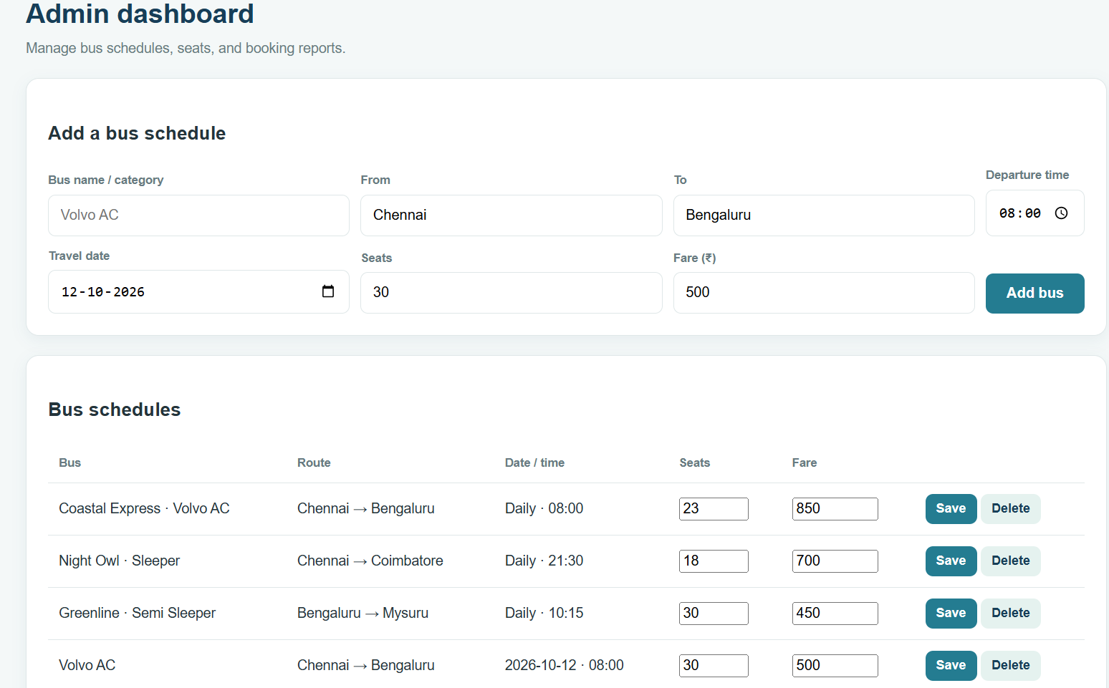
ADMIN PANEL

RESULT
The Bus Ticket Booking System was designed to support user registration and login, bus search, seat selection, ticket booking and cancellation, comments, and booking history. The administrator can maintain bus categories and information, manage users and news, and generate reports.

